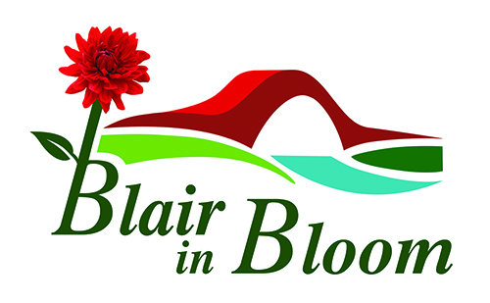

Minutes of Committee Meeting held on

3rd April 2023

At Downfield, Coupar Angus Road, PH10 6JY

1 | Apologies for Absence  Mary Birch and Cllr Caroline Spiers.
2 | Minutes of Previous Meeting:  Approved by Avril Wilson. Seconded by Jean Smith
3. | Matters Arising:  Plug plants arriving first week in May (usually Wednesday).  Plants being delivered to the Community Garden and someone must be there to take delivery.  Contact Elspeth at PKC to confirm funding will be £1800 as in the past.  Guides:  To be notified to contact Pat if and when they wish assistance with their planting plan.  A visit to Kinross Community Garden had been arranged by Avril for 29th April at 2pm. Avril, Jean, Morag, Pat and Cathy will visit. Thanks to Avril for arranging.  New Web Page and email addresses:  Jean, William and Cathy to be given further instruction from Steve. To be arranged asap. | WW  CD  WW
4.  5  6.  7. | Volunteers:  A coffee and a chat after work on a Monday is proving a success and will continue meantime.  It was agreed a short update on work being done and progress on projects will be sent out by email on a Monday to all volunteers.  When Minutes of Meetings sent to volunteers they will be invited to submit any comments, ideas or suggestions to the Committee for consideration at the next Meeting.  New Equipment:  Currently with Jean but will be housed in the Tractor Shed at the Community Garden.  Grass Seed required for the Community Garden after construction work completed. Request BRDT to finance.  Gravel and Polytunnels:  Gravel donated from lady in Woodlands Road has now been collected and stored at the Community Garden. Two polytunnels still to be collected by end of April.  Coronation Corner:  After work on Monday 8th May volunteers will be invited to stay and have a cup of coffee and a cake to celebrate the Coronation. There will also be a small plant sale.  The Blairgowrie Advertiser to be notified of the event and Sam Stewart will promote the event as it is Volunteer Day and hopes this may encourage more people to see what we are about and hopefully join us as volunteers.  Treasurer’s Report:  £4018.76 in Bank. £390 made on Tesco Raffle  £100 Paid to BRDT for Website and £642 to David Glover Garden Works  £800 to Moyness for Plant leaving approximately £3200 Cash available.  Plug Plants costing £1100 hopefully financed by PKC at £1800  Businesses in town to be approached with regard to sponsoring hanging baskets at £50.00 per basket  Fund Raising:  It was agreed to put a calendar together with dates of all fund raising activities that take place throughout the year, and that a Fund Raising Item be put on the Agenda monthly.  Tasks and Priorities List – see attached  AOCB:  Judging this year: The Committee were undecided as to whether we should enter the Beautiful Scotland Awards this year so it was decided to ask the volunteers. An email will be sent to everyone asking for their opinion and the Committee will go with the majority decision.  Pop Up Shop: Sam Stewart is in talks with Laura Gray regarding properties around the town and also with Howes as it appears their shop may again be available to rent in the future. Sam will update us asap on this.  Blueberry Bushes: Morag to email Mary with regard to the Blueberry bushes offered to us.  Data Protection:  In order to comply with the legal requirement for data protection a form has been devised to be signed by all members of Blair in Bloom consenting to their email address being used as necessary by the organisation . This form will be sent by email but paper copies will also be available for those who cannot print off form.  Victoria Community Gardens at Dundee would welcome us on a visit. Jean to organise.  Date of Next Meeting:  Monday 8th May at 6.30pm at 7 Manor Gardens, Blairgowrie. | AW/PL  CD  WW  WW  AW/PL/JS  CD  CD  SS  MR  CD  JS

